**COVID-19 Data Analysis in India**

**Objective**

A comprehensive COVID-19 dashboard finds real-time updates on cases, deaths, and recoveries, analyse trends and demographics, assess geographic and healthcare system impacts, track testing and vaccination rates, monitor epidemiological metrics In India.

**Research Question**

* In The given data, find out in which state of India is high death count.
* According to the given data to find out which is age group of people in India was most affected by Covid 19.
* As per the given data find out the Covid Confirm , Death and cured case numbers as per the state wise.
* Finding the ICMR testing lab number in state wise.
* Find the Covid case ratio gender wise in given data.
* In given data find the number of Positive case negative case, sample case as per state wise.
* Find the Number of people has taken the first vaccine and 2nd vaccine.
* Find the total number of given vaccine dose as per brand name.

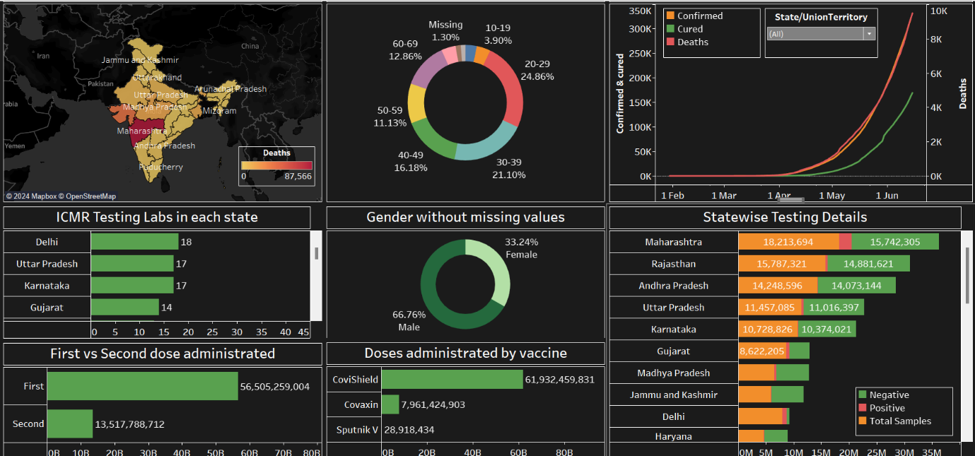

**Insights and finding.**

* Analysis of the given data so that the Indian State of Maharashtra and Gujarat have been most affected by Covid 19 and there is high death count.
* From the analysis of Dashboard, we can see that the maximum Covid case ratio in age wise is between 20 to 29 years and least Covid case in between 10 t0 19 years.
* As given Dash board we can see the Covid confirm, death and cured case as per state wise where we find the maximum death case is in the Maharashtra state and the maximum confirm case is in Gujarat and the maximum cured case find in Madhya Pradesh.
* In given data we find the maximum number of ICMR test lab in Delhi and second in Uttar Pradesh.
* In this analysis we find the male gender is affected 66.76% but female gender affected only 32.24%.
* In this dashboard we can clearly find Negative, positive and sample collection case numbers as per state wise.
* According the given data we can find the total number of first dose and second dose given.
* We can also get the number of vaccines in brans (name) wise.

**Summary**

The data analysis reveals that Maharashtra and Gujarat are the most severely affected Indian states, experiencing high death counts due to COVID-19. The age group most impacted is between 20 to 29 years, while those aged 10 to 19 years show the lowest number of cases. State-wise, Gujarat reports the highest confirmed cases, Maharashtra records the maximum deaths, and Madhya Pradesh leads in recoveries. Delhi hosts the highest number of ICMR test labs, followed by Uttar Pradesh. Gender-wise, 66.76% of cases affect males, with females constituting 32.24%. The dashboard provides a detailed breakdown of COVID-19 cases, vaccinations, and vaccine brand-specific information, offering a comprehensive overview of the pandemic's impact across different parameters.